

# “CouchMovies” Demo Script

## Document Inspection

Go to the Documents tab in the Server console.

Let’s have a look at one of the movies in our movie database. On the Documents page, we can view and/or edit any document in the system or look for example documents of a certain type. Let’s look for information about ‘Avengers: Endgame’. In this case, we don’t know they key of the document we want, but we do know we are looking for a movie document and we know the title.

Enter the following into the Where search box of the Document page

type="movie" and title="Avengers: Endgame"



Click on the movie key (or the edit button) to open the document in the document editor.

From here, we can a number of things. Firstly, the entry is truly a JSON document.

One of the first things we see, since the entries come back sorted alphabetically, is that each movie document contains a collection of sub-documents, one for each cast member. Each entry in the collection of cast members is a JSON document itself, and describes a role, played by an actor in this particular film. In a relational database, because of this one-to-many relationship, we would have to break these roles out into a separate detail table for storage, and then use a JOIN to bring the information back together when we wanted to display the movie. From a performance point of view, the best way to optimize the performance of a JOIN is to not do a JOIN in the first place. This is one of the super powers of a JSON database – selective denormalization. Many of the extensions to the SQL language that form the ‘++’ in ‘SQL++’ have to deal with the ability to include these sub document collections in indices and queries.

This is not to say that we can’t do a JOIN when we need to – Couchbase absolutely can, and we will see this in a minute.



Collapse the ‘cast’, ‘collection’, ‘crew’, ‘genres’, ’production_companies’, ‘production_countries’, and ‘spoken_languages’ (essentially all large arrays) fields.

Down near the bottom of the document, we will see information that makes sense to store for each movie, such as ‘title’, ‘release_date’ and ‘overview’.



Let’s go back to the Documents page and look at the document where we store particular information about Robert Downey Jr. that is not specific to his role in this particular film.

Go back to the Documents page. Change the Where field to the following:

type="person" and primaryName="Robert Downey Jr"

Click on the document key or edit button to view the person document.



I’m not storing a lot of information on each person here, just enough to demonstrate how we can join the cast information with the person information. Here at least we can see that RDJ was born in 1965. That makes him two years older than I am and gives me two whole years to start an acting career and star in an Avenger movie if I want to catch up.

Close the document editor.

## N1QL Demo

Go the Query page of the Server console.

Let’s execute some SQL queries against this movie data. Let’s start with a simple query to find the profit earned on Avengers: Endgame.

Enter and execute the following query (or access via history).

SELECT title, revenue, budget, revenue - budget as profit

FROM moviedata

WHERE type="movie"

AND title="Avengers: Endgame"

We can see a revenue of $2.8 Billion for a budget of $356 Million – nice job! That kind of profit will more than pay for some Couchbase licenses!



Here in the Query Results section, we can see that the result of a N1QL query is itself a collection of JSON documents, only in this case, a collection with a single entry. This is really powerful, because many of applications that want to use the data, like JavaScript-based UIs or RESTful micro-services, all want to deal with JSON documents, so the application server can pass the result of the query right through to the application. You even have a lot of control of how the result document is formatted in your projection clause – notice how I was able to give an alias ‘profit’ to the calculation, and that showed up as the key in the JSON document.

Now lets’ leverage the cast collections in each movie to go and find the revenue of all RDJ movies, without doing a JOIN.

Enter and execute the following query (or access via history).

SELECT title, revenue

FROM moviedata

WHERE type="movie"

AND ANY member IN `cast` SATISFIES member.name = "Robert Downey Jr" END

ORDER BY revenue DESC

The ‘ANY-IN-SATISFIES’ clause in this statement is used to iterate through the cast collection and select certain rows. Again, the result is a collection of JSON documents, but the UI gives us a tabular view of the data if we prefer that.

Click on Table to display the results as a table.



Queries in N1QL can be optimized by defining a secondary index that supports the query. This is also true of queries that access sub collections as well, as we can see by looking at the index definition for this query.

Open the Indexes page, select the idx_castName and highlight the code used to create this index.



We can also view the query plan to confirm that our query is using the correct index. Our current beta release will also suggest indices that you could add to speed up any slow running queries, but, that kind of implies that any queries run slowly in Couchbase, so I doubt this feature will be used much. <sarcasm>



So, our last query found movies that RDJ was in. Now, lets’ change our query to find out who has acted with RDJ in a movie.

Enter and execute the following query (or access via history).

SELECT DISTINCT moviedata.title, actor.name

FROM moviedata

UNNEST `cast` actor

WHERE moviedata.type="movie"

AND ANY member in moviedata.`cast` SATISFIES member.name = "Robert Downey Jr" END

The UNNEST clause causes the nested cast collection to be expanded, so that the alias ‘actor’ has one row per cast member, but each row still logically contains information about the movie it is associated with.

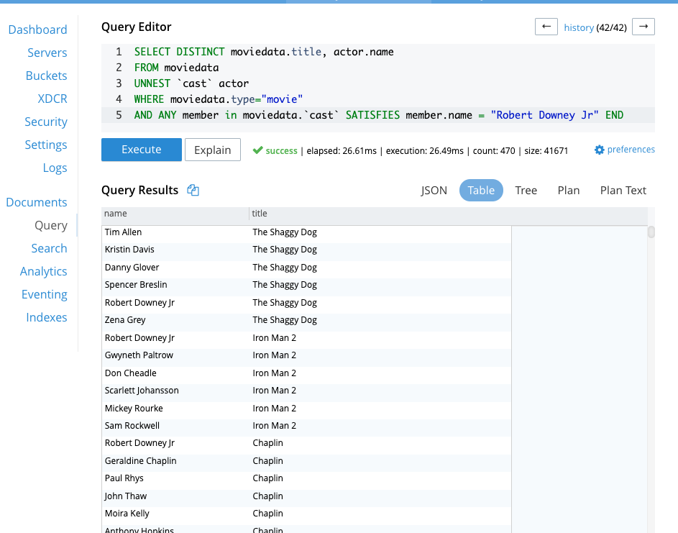

And lastly, I will demonstrate doing both an UNNEST and a JOIN that will allow me to get the actor’s birth year – which we saw was stored in the person object - by joining the cast members’ name to the person document’s primaryName. And to show that we support a full set of SQL functions, I’ll GROUP the result by the movie name and SORT the results DESC.

Enter and execute the following query (or access via history).

SELECT FLOOR(AVG(person.birthYear)) as year, movie.title

FROM moviedata as movie UNNEST movie.`cast` as actor

JOIN moviedata AS person

ON actor.name = person.primaryName

AND person.type = "person"

WHERE movie.type = "movie"

AND ANY member IN movie.`cast` SATISFIES member.name = "Robert Downey Jr" END

GROUP BY movie.title

ORDER BY year DESC

The results show us the average year of birth of RDJ co-stars in various movies. I think that Endgame would have been a lot higher in this ranking if Samuel L. Jackson hadn’t shown up in the last few seconds of the movie.



NOTE: The underlying data is not very hygienic. It has been arduously cleaned so that the above query works without having any actors with a null birthyear. You can add AND person.birthYear IS NULL to the query to deal with this, but it’s less impressive.

## Full Text Search Demo

Now let’s look at the Full Text Search features of Couchbase. Full text indices are different than N1Ql indices, in fact, they are inverse indices, so we have a different section of the UI to create and manage them.

Open the Search page on the Server console, select the ‘movies_shingle’ index and then select Edit to expose the index definition.



We don’t have time to get into the details of how Full Text Search indices are defined, but you can see here that I have selected the fields that I want included in the index, including some numeric fields, like ‘release_year’ - we will see that field featured as a search facet in a minute. If your eyesight is good enough, you will see that I can also add fields like the cast member’s name and the name of the character they played, even though that information is contained in the collection of cast documents.

If you are familiar with Full Text Search, you will probably understand the concepts of filters, stop words and analyzers, which are used to do things like strip out punctuation, remove common words like ‘a’, ‘and’ and ‘the’, and to understand that words like ‘beauty’ and ‘beautiful’ are essentially the same from a search perspective in the English language. Couchbase includes analyzers for 28 different languages and allows you to also define your own custom analyzers when, for example, you need to deal with industry specific terms.

While we could execute a Full Text Search here from the Administrator’s UI, let’s jump to an example application I’ve put together to show Full Text Search in action.

Open couchmovies.html

Let’s start with a simple search for Avengers.



Notice that Avengers: Endgame is coming up at the top of the list. This is no accident. The code that executes this query leverages a number of different fields, such as release_year, popularity, movie collections etc, and weights the value of each to give each movie in the result set a score.

If I select Avengers: Endgame, I can get the movie details.

Select the poster for Avengers: Endgame



On the right-hand side of this screen I’ve displayed some of the information that came back with the query (as, you guessed it, a JSON document). The results tell us how the score was calculated, but that’s a little too complex to show here. But we can see where Couchbase found the word ‘Avengers’ in this movie description, and some context – called a fragment – that shows the words around the search word.

Now let’s look at the filtering options provided by our facets. A Facet is a summarization of the result set that is effectively GROUPed BY one of the available dimensions of the data. Here I’ve added facets for the movie genre and for the release year.

Click on the ‘+Facets’ link and show the options for the Genres facet. Then show the option for the Release Year facet.





Notice in the Release Year options, some options are a single year, and others span multiple years. This is intentional, and easy to do. For this use case, I personally find it easy to remember movies that are recent, but have a tough time remembering particular years for movies in the past. Notice also that the facet is telling us how many options from the current search satisfy that option.

Select the 2019 Release Year option.

We can click on 2019 show us just the Avenger movies released in that year.

Click in the Release Year facet option and also select 2018.

And, we could easily add movies release in 2018 as well.



Change the search word to ‘Thanos’. From the results, select Infinity Wars.

We can search for any term in the movies. Let’s use ‘Thanos’ as an example.



We can see that ‘Thanos’ shows up in two results, and in Infinity Wars, the word occurs both as a character name and as one of the words in the movie overview.

Select the ‘Fuzzy Search’ check box, move your cursor to the search field after ‘Thanos’ and hit enter. Choose ‘Thanks for Sharing’.

A fuzzy search allows for spelling errors, is configurable with respect to ‘how fuzzy’ and uses something called the Levenshtein distance to decide how relevant words may be. Notice that if we do a fuzzy search for Thanos, we get movies with include the word ‘Thanks’, and – oh oh – here we find a movie with Pepper Potts cheating on Tony Stark with Bruce Bannon. Awkward.

